DISH RACK

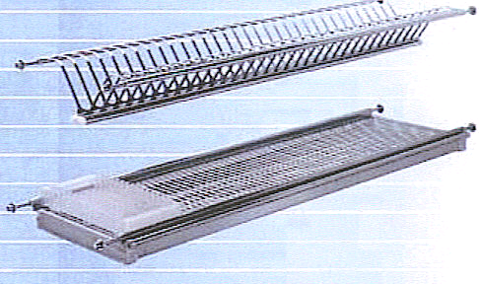

SUSBK065

Material: Stainless Steel
Length available: 600mm, 800mm, 900mm

