FUNCTION COLUMN SYSTEM
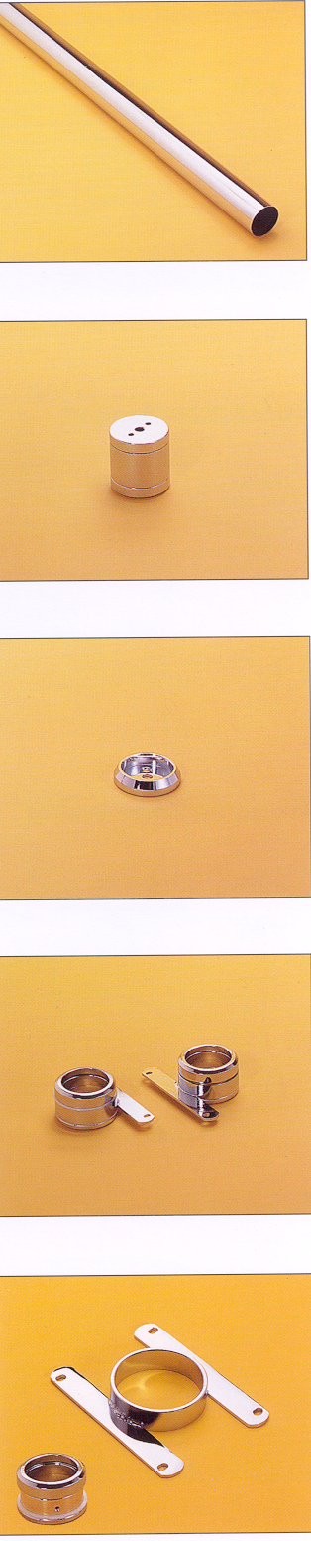
Pole, Ø50mm
Item No. | Body Size | Material & Finish
Item No. | (dia. x length)mm | Material & Finish
B29408 | Ø50 x 820 | S.S. with chrome plated
B29412 | Ø50 x 1220 | S.S. with chrome plated
B29418 | Ø50 x 1820 | S.S. with chrome plated
B29426 | Ø50 x 2620 | S.S. with chrome plated
B29430 | Ø50 x 3020 | S.S. with chrome plated

Top Fastener
Item No. | Body Size | Material & Finish
Item No. | (dia. x length)mm | Material & Finish
B29506 | Ø67 x 70 | brass with chrome plated

Bottom Fastener
Item No. | Body Size | Material & Finish
Item No. | (dia. x length)mm | Material & Finish
B29507 | Ø67 x 15 | brass with chrome plated

Shelves Support
Item No. | Body Size | Material & Finish
Item No. | (WxDxH)mm | Material & Finish
B29520 | 130 x 82 x 42 | S.S. with chrome plated

Shelves Connecter
Item No. | Body Size | Material & Finish
Item No. | (WxDxH)mm | Material & Finish
B29525 | 130 x 97 x 42 | S.S. with chrome plated

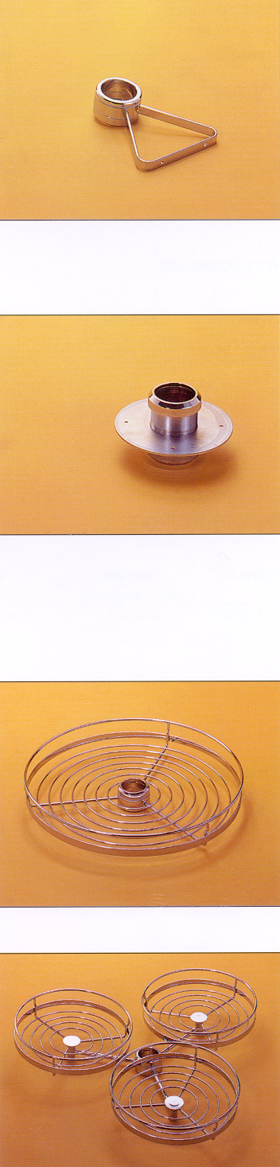

Pole Support, on wall
Item No. | Body Size | Material & Finish
Item No. | (WxDxH)mm | Material & Finish
B29510 | 140 x 177 x 42 | S.S. with chrome plated
B29515 | 140 x 312 x 42 | S.S. with chrome plated

Swivel Table Support
Item No. | Body Size | Material & Finish
Item No. | (dia. x height)mm | Material & Finish
B29530 | Ø150 x 94 | S.S. with chrome plated

Revolving Single Basket
Item No. | Body Size | Material & Finish
Item No. | (dia. x height)mm | Material & Finish
B29602 | Ø450 x 70 | S.S. with chrome plated

Swing Triple Basket
Item No. | Body Size | Material & Finish
Item No. | (dia. x height)mm | Material & Finish
B29606 | Ø300 x 70 | S.S. with chrome plated

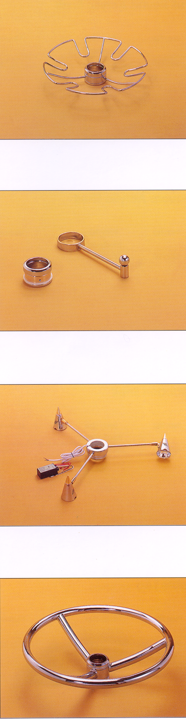
Glass Rack
Item No. | Body Size | Material & Finish
Item No. | (dia. x height)mm | Material & Finish
B29640 | Ø315 x 55 | S.S. with chrome plated

Hanging Rack
Item No. | Body Size | Material & Finish
Item No. | (L x H)mm | Material & Finish
B29661 | 160 x 42 | S.S. with chrome plated

Spotlight Set
Item No. | Body Size | Material & Finish
Item No. | (dia. x height)mm | Material & Finish
B29670 | Ø460 x 70 | S.S. with chrome plated

Foot Rest
Item No. | Body Size | Material & Finish
Item No. | (dia. x height)mm | Material & Finish
B29680 | Ø450 x 120 | S.S. with chrome plated

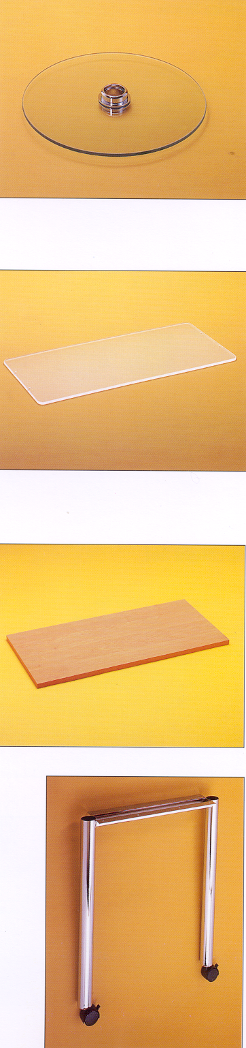
Full Round Acrylic Shelf
Item No. | Body Size | Material & Finish
Item No. | (dia. x height)mm | Material & Finish
B29710 | Ø450 x 42 | acrylic

Square Acrylic Shelf
Item No. | Body Size | Material & Finish
Item No. | (WxDxH)mm | Material & Finish
B29720 | 900 x 350 x 80 | acrylic

Wooden Shelf
Item No. | Body Size | Material & Finish
Item No. | (WxDxH)mm | Material & Finish
B29730 | 900 x 350 x 18 | plywood

Table Leg, on wheel
Item No. | Body Size | Material & Finish
Item No. | (WxDxH)mm | Material & Finish
B29905 | 540 x 110 x 670 | S.S. with chrome plated

