DRAWER SLIDE

Descriptions |  |  | 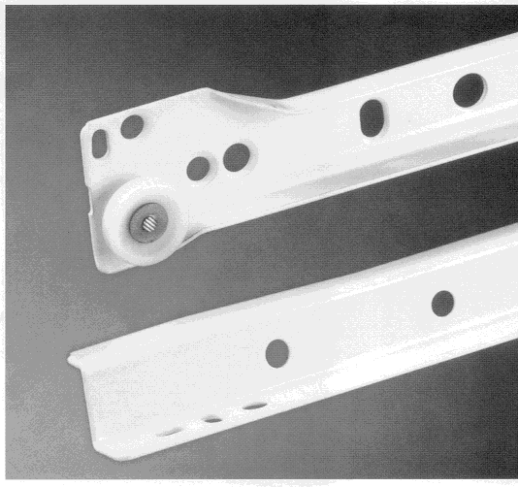
• Single extension
• Epoxy Coated
• Bottom mounted drawer profile
• Lateral stability due to captive roller design
on right side. Left hand side provides for
tolerance adjustment
• Superior roller mechanism - Spins on washer
not on channel
• 25kg load capacity
• Double stop, roll out prevention
• Locked in position when extended

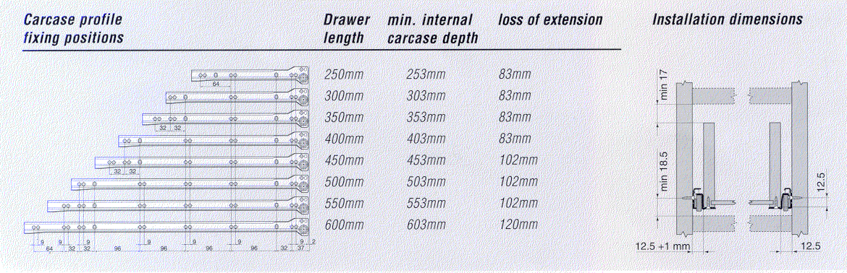

HA.1012/30 Bottom Mounting Single Extension Slide 300mm, R9001
HA.1012/35 Bottom Mounting Single Extension Slide 350mm, R9001
HA.1012/40 Bottom Mounting Single Extension Slide 400mm, R9001
HA.1012/45 Bottom Mounting Single Extension Slide 450mm, R9001
HA.1012/50 Bottom Mounting Single Extension Slide 500mm, R9001
HA.1012/55 Bottom Mounting Single Extension Slide 550mm, R9001
HA.1012/60 Bottom Mounting Single Extension Slide 600mm, R9001

