Furniture Handle
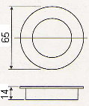
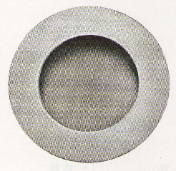

Finishes | Stainless Steel | Brass
Finishes | Satin, Polished | P&L, S&L, AB, CP, NP, GP
Sizes | ∅ 65x14mm | ∅ 30x12mm
Sizes | ∅ 65x14mm | ∅ 35x12mm
Sizes | ∅ 65x14mm | ∅ 40x12mm
Sizes | ∅ 65x14mm | ∅ 50x12mm
AH.FH0010SS

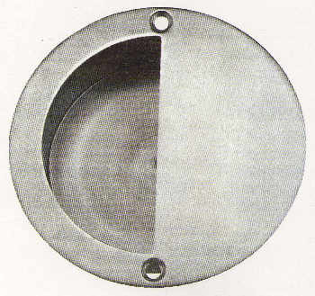

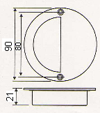

AH.FH0020SS
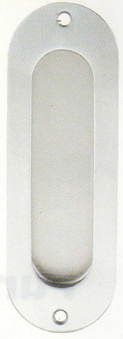

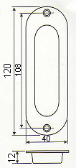

AH.FH0030SS

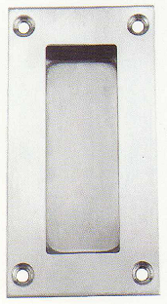

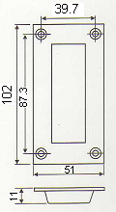

AH.FH0040SS

