**EURO PROFILE CYLINDER**

**Definitions of cylinder lengths:**

The length will be declared up to the middle of the cylinder screw. The outside “A” and the inside “B” for profile cylinders has to be declared separately.

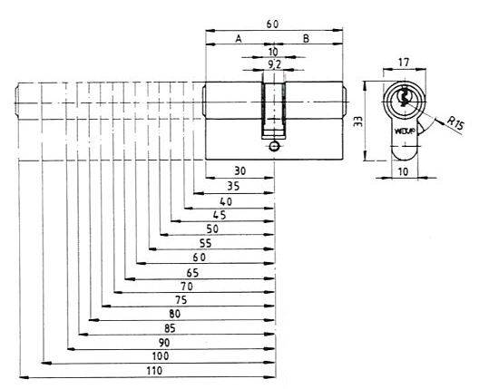

**Function:**

1. Double Function

2. Single Entry Function

3. Radial Function

4. Privacy Function

**Key For Keying Systems**

1. Grand Master Key

2. Master Key

3. Group Key

4. Key Aliked

5. Single Key

**Key Alike System**

Two or more cylinders have the same individual key. They may or may not be part of keying system (the same key can operate two or more locks.)

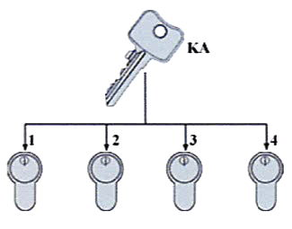

Notice:

Key Alike (KA) can operate locks no.1-4

**EURO PROFILE CYLINDER**

**Master Key System**

All cylinders have their own keys. The single-key passes only one cylinder. The master-key passes all cylinders of the system.

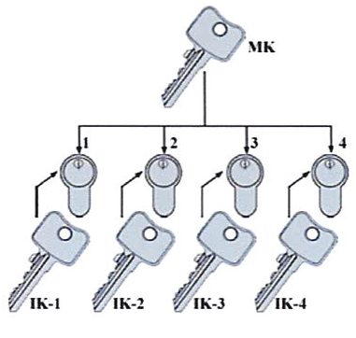

Notice:

Master Key:

MK can operate lock no.(1-4)

Individual Key:

IK-1 can operate lock cylinders 1

IK-2 can operate lock cylinders 2

IK-3 can operate lock cylinders 3

IK-4 can operate lock cylinders 4

**Grand master Key System**

Is the concentration of different master-key systems as one system. The grand-master-key passes all locks, the master-key passes all locks of the region, the single key passes only one cylinder.

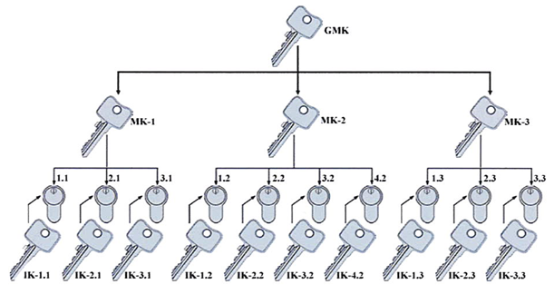

Master Key:

MK-1 can operate lock no.(1.1 - 3.1)

MK-2 can operate lock no.(1.2 - 4.2)

MK-3 can operate lock no.(1.3 - 3.3)

Individual Key :

IK-1.1 can operate lock cylinder 1.1

IK-2.1 can operate lock cylinder 2.1

IK-3.1 can operate lock cylinder 3.1

**EURO PROFILE CYLINDER**

**Knob Series**

  

**Knob No. 1 Knob No. 2 Knob No. 3**

 

**Double Entry Function Single Entry Function**

 

**Privacy Function Security & Safety Lock**

 

**Half Cylinder Half Cylinder With Knob**

|  |  |  |
| --- | --- | --- |
| **A (mm)** | **B (mm)** | **C (mm)** |
| 65 | 32.5 | 32.5 |
| 70 | 35 | 35 |
| 80 | 40 | 40 |
| 90 | 45 | 45 |
| 100 | 50 | 50 |
| 110 | 55 | 55 |
| 120 | 60 | 60 |

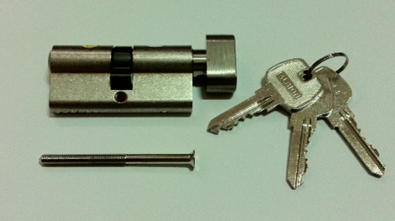

**EURO PROFILE CYLINDER**

|  |  |  |
| --- | --- | --- |
| **A (mm)** | **B (mm)** | **C (mm)** |
| 65 | 32.5 | 32.5 |
| 70 | 35 | 35 |
| 80 | 40 | 40 |
| 90 | 45 | 45 |
| 100 | 50 | 50 |
| 110 | 55 | 55 |
| 120 | 60 | 60 |



|  |  |  |
| --- | --- | --- |
| **A (mm)** | **B (mm)** | **C (mm)** |
| 65 | 32.5 | 32.5 |
| 70 | 35 | 35 |



|  |  |  |
| --- | --- | --- |
| **A (mm)** | **B (mm)** | **C (mm)** |
| 40 | 30 | 10 |
| 45 | 35 | 10 |

 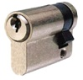

|  |  |  |
| --- | --- | --- |
| **A (mm)** | **B (mm)** | **C (mm)** |
| 65 | 32.5 | 32.5 |
| 70 | 35 | 35 |

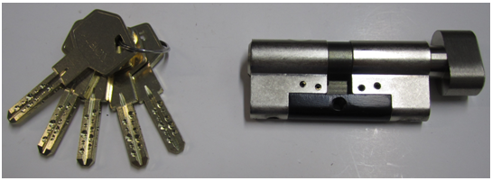

**Available Finishes:**

AB – Antique Brass

PB – Polished Brass

SN – Satin Nickel