DOUBLE ACTION SPRING HINGE

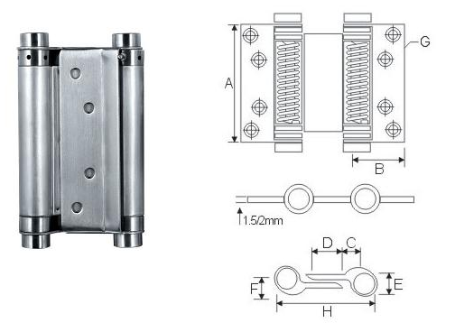

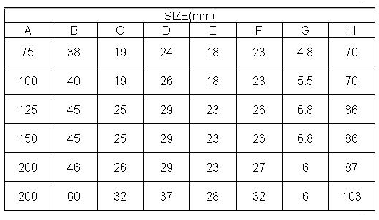

Material : SUS 304 Stainless Steel
Finish : Satin Stainless Steel (SSS)

