DOOR CLOSER

A3070 Series

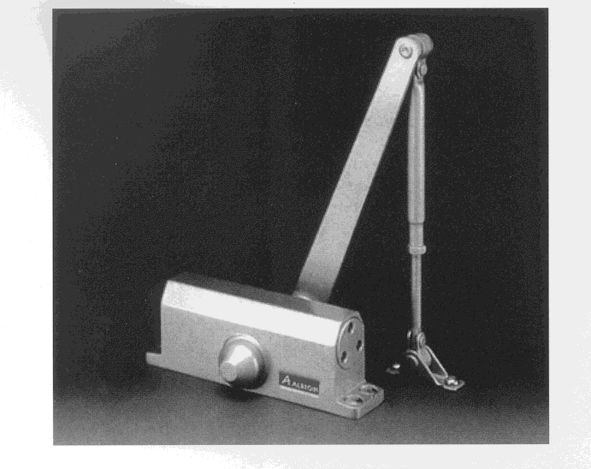
AH.A3077BC – With back check function

AH.A3077FS – With free swing function

AH.A3077HO – With hold open function

IDW: 1050mm
Max. Door Weight: 60kg

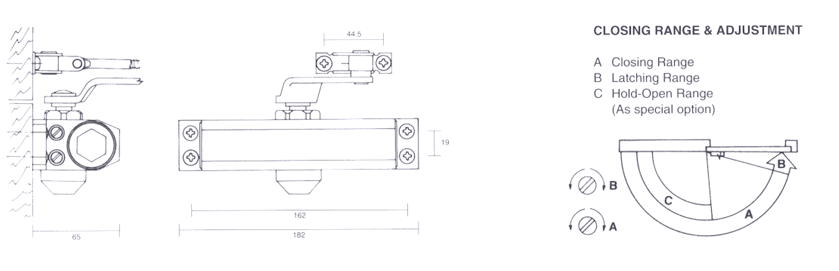

Universal Surface Mounted Door Closer:
Reversible for left or right doors, die-cast aluminum housing with a hardened steel rack and pinion mechanism.

Adjustment:

Two independent valves providing hydraulic control from 180° of closing sweep and 15° of latching. Fully adjustable after installation.

Finishes:
Excellent finish in Aluminum. Other finishes are available upon request.

Available Size:
Size 2 and Size 3

REVERSIBLE CONCEALED DOOR CLOSER

A4090 Series (Non-Handed)

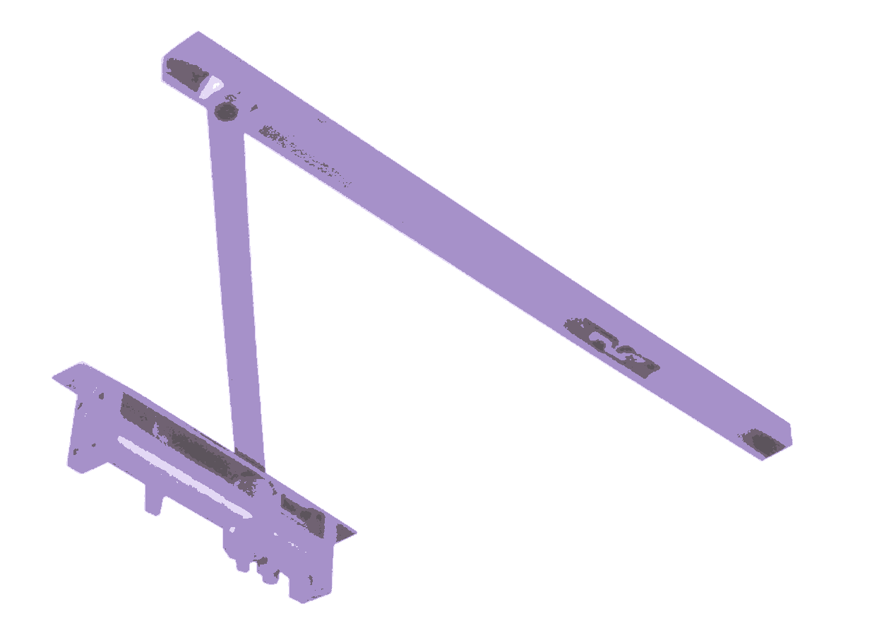
AH.A4096BC – With back check function

AH.A4096FS – With free swing function

AH.A4096HO – With hold open function

IDW: 1050mm
Max. Door Weight: 60kg
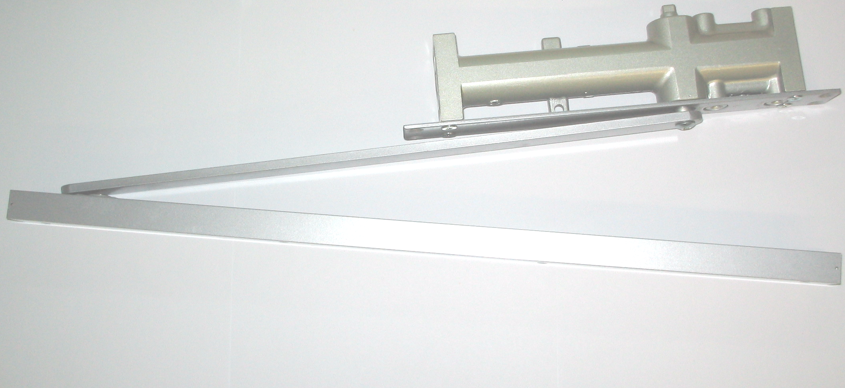

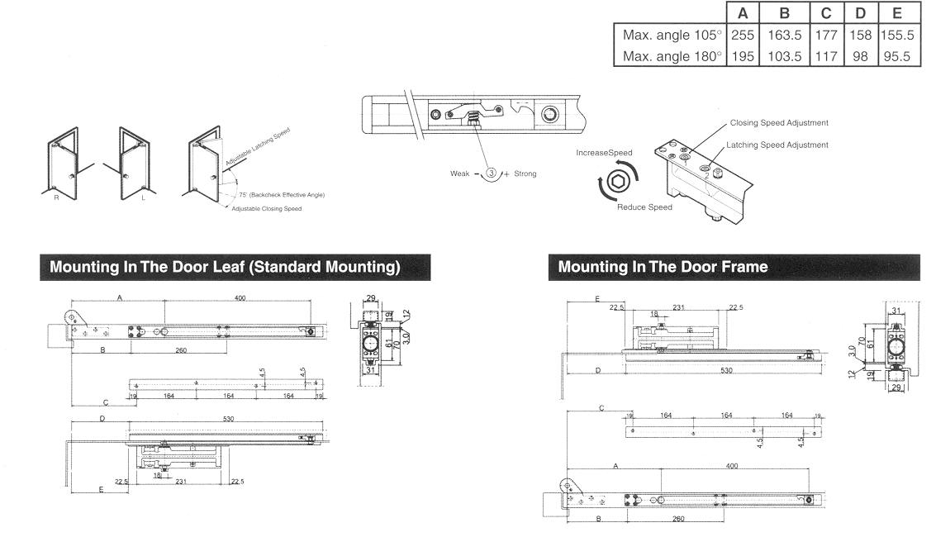

DOOR CLOSER

A9026 Series
AH.A9014BC – With back check fuction (Size 1-4)

AH.A9026BC – With back check function (Size 2-6)

AH.A9026BC/DA– With back check and delay action

Mounting in the door leaf BC (Size 1-4)

Mounting in the door leaf BC/DA (Size 2-6)

Item | Dimension of Product |  | Suit For Door Weight
Item | Length | Width | Suit For Door Weight
AH.9014BC | 227.0mm | 61mm | 15 ~ 100Kg
AH.9026BC | 287.5mm | 61mm | 25 ~ 180Kg
AH.9026BC/DA | 287.5mm | 61mm | 25 ~ 180Kg
DOOR CLOSER

A6077HO Series

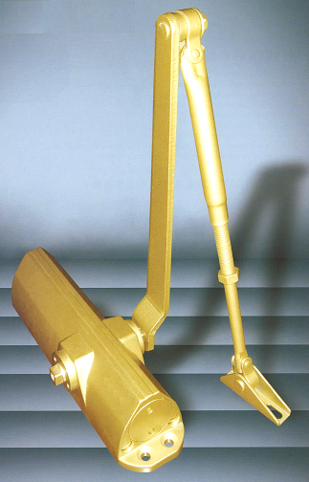

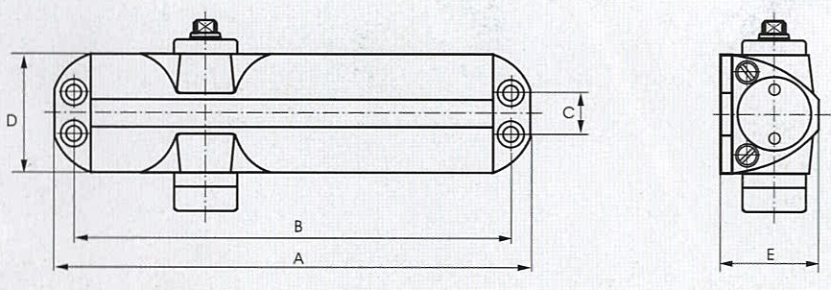

- Universal Application. For standard, Top-Jamb or Parallel Arm Installation.
- High Quality Cast Aluminum Alloy Case.
- Speed Are Easy To Adjust, Two Separate Closing & Latching Speed Valves Adjust From 180°~15°~0°
- Easy & Fast Installation With Mounting Paper Template.

Item | Dimension of Product |  | Suit For Door Weight
Item | Length | Width | Suit For Door Weight
AH.6077HO | 220mm | 53.5mm | 25-60 Kg

