HIGH SECURITY CYLINDER

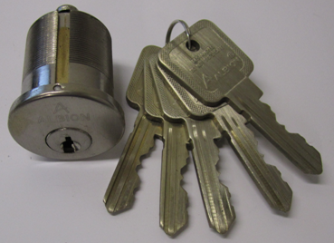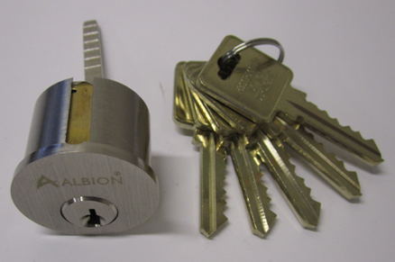
AC.P03-S1-1.5-SN AH.CYL-60-SN

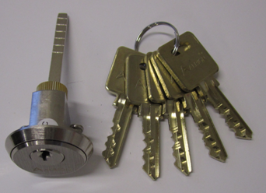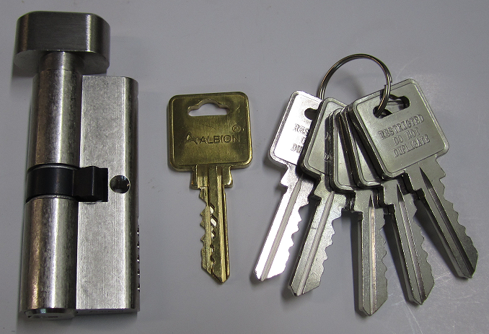
AH.CYL-80-SN AH.85-71-SN

Available Finish:
1) Antique Brass
2) Polished Brass
3) Satin Nickel

