DOOR HINGE

2 Ball Bearings Hinge
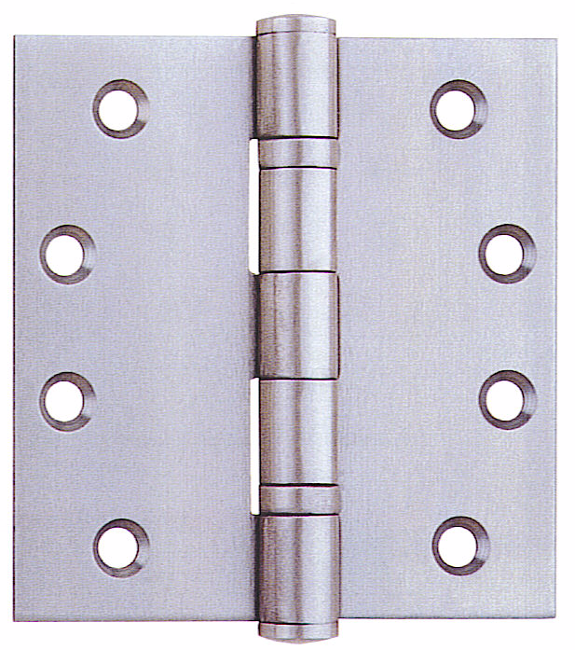

Sizes Available:
4” x 3” x 2mm
4” x 3” x 2.5mm
4” x 3” x 3mm
5” x 3.5” x 3mm

* Other sizes available upon special request

SS- Stainless Steel
PSS- Polished Stainless Steel
BP- Brass Plated
GP- Gold Plated (Shining)
AB- Antique Bronze
AC- Antique Copper
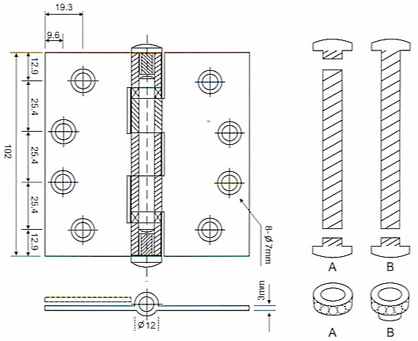

4 Ball Bearings Hinge

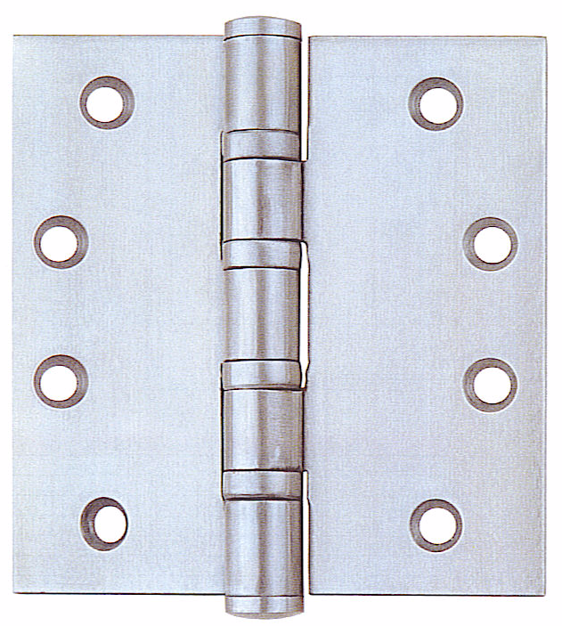

Sizes Available:
4” x 3” x 3mm
5” x 3.5” x 3mm

* Other sizes available upon special request

SS- Stainless Steel
PSS- Polished Stainless Steel
BP- Brass Plated
GP- Gold Plated (Shining)
AB- Antique Bronze
AC- Antique Copper

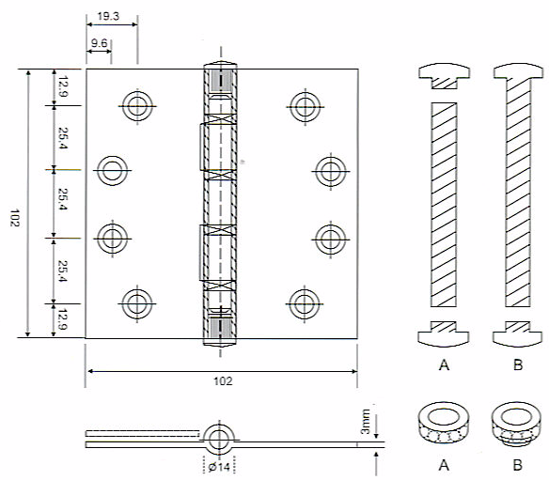

5/8” Round Corner Hinge

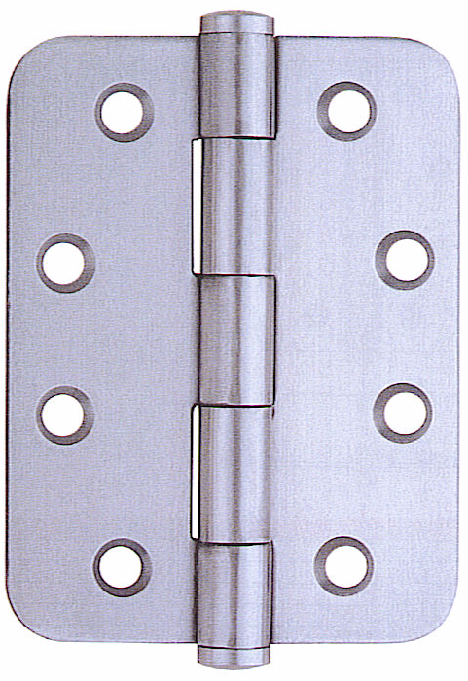

Sizes Available:
4” x 3” x 3mm
5” x 3.5” x 3mm

* Other sizes available upon special request

SS- Stainless Steel
PSS- Polished Stainless Steel
BP- Brass Plated
GP- Gold Plated (Shining)
AB- Antique Bronze
AC- Antique Copper

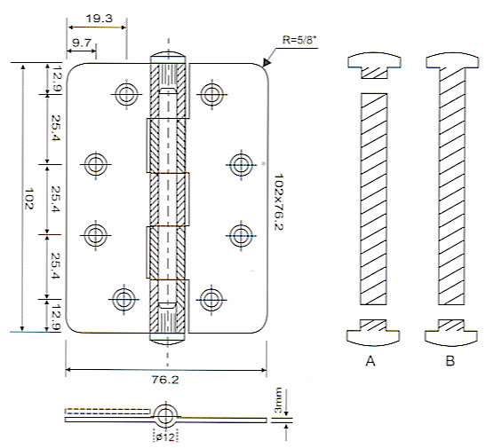

One-Leaf Round Corner Hinge

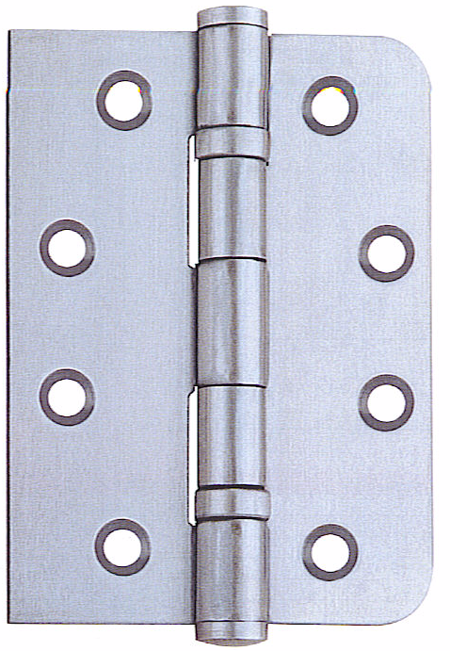

Sizes Available:
4” x 3” x 3mm
5” x 3.5” x 3mm

* Other sizes available upon special request

SS- Stainless Steel
PSS- Polished Stainless Steel
BP- Brass Plated
GP- Gold Plated (Shining)
AB- Antique Bronze
AC- Antique Copper

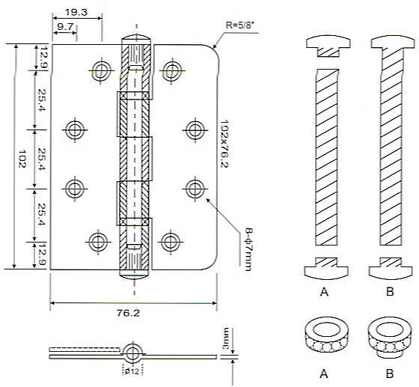

Lift-off Hinge With Washer

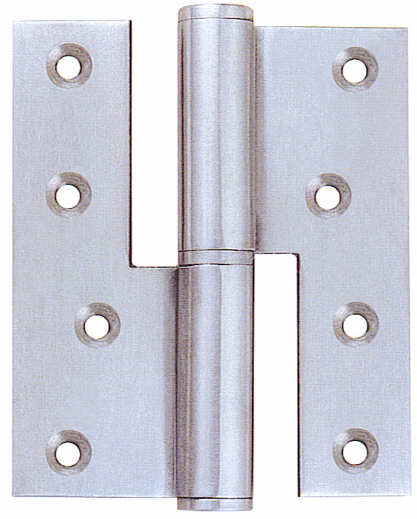

Sizes Available:
4” x 3.5” x 3mm

* Other sizes available upon special request

SS- Stainless Steel
PSS- Polished Stainless Steel
BP- Brass Plated
GP- Gold Plated (Shining)
AB- Antique Bronze
AC- Antique Copper

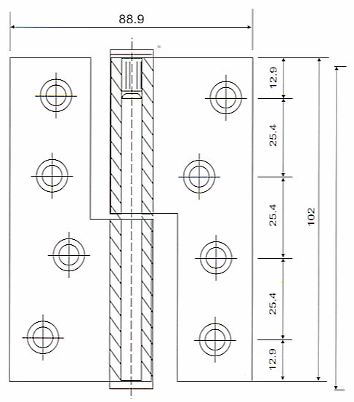

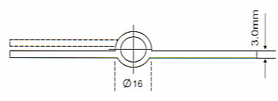

Round Corner Lift-off Hinge

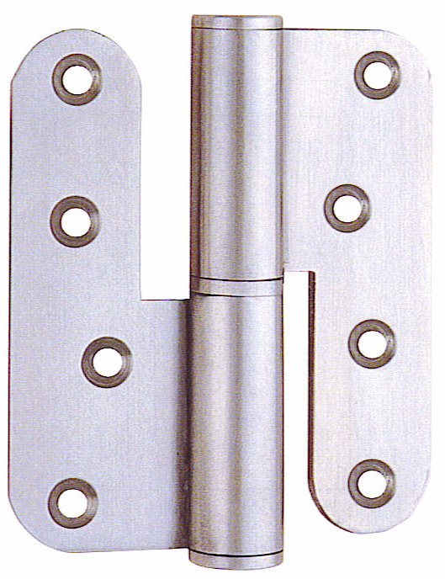

Sizes Available:
4” x 3.5” x 3mm

* Other sizes available upon special request

SS- Stainless Steel
PSS- Polished Stainless Steel
BP- Brass Plated
GP- Gold Plated (Shining)
AB- Antique Bronze
AC- Antique Copper

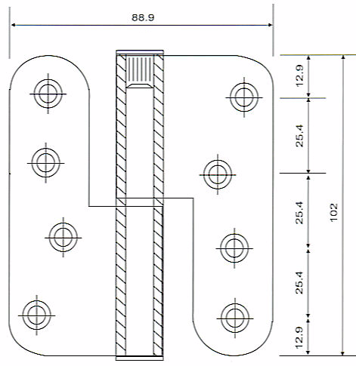

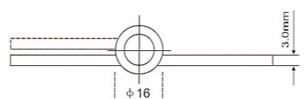

Lift-off Rising Hinge
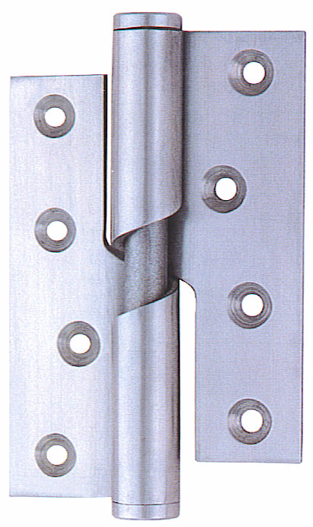

Sizes Available:
4” x 3” x 3mm

* Other sizes available upon special request

SS- Stainless Steel
PSS- Polished Stainless Steel
BP- Brass Plated
GP- Gold Plated (Shining)
AB- Antique Bronze
AC- Antique Copper

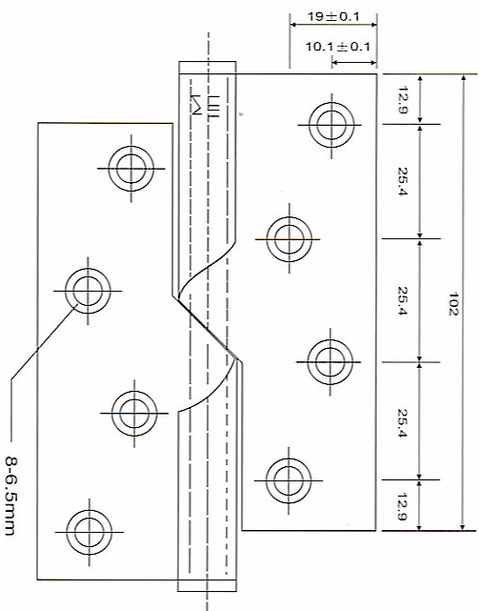

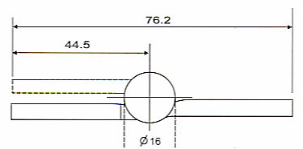

Flag Hinge With Washer
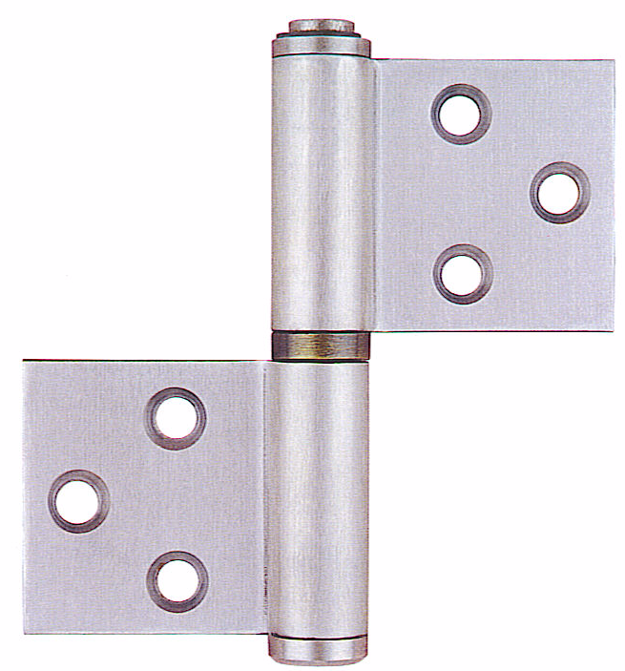

Sizes Available:
127mm x 45mm x 3mm

* Other sizes available upon special request

SS- Stainless Steel
PSS- Polished Stainless Steel
BP- Brass Plated
GP- Gold Plated (Shining)
AB- Antique Bronze
AC- Antique Copper

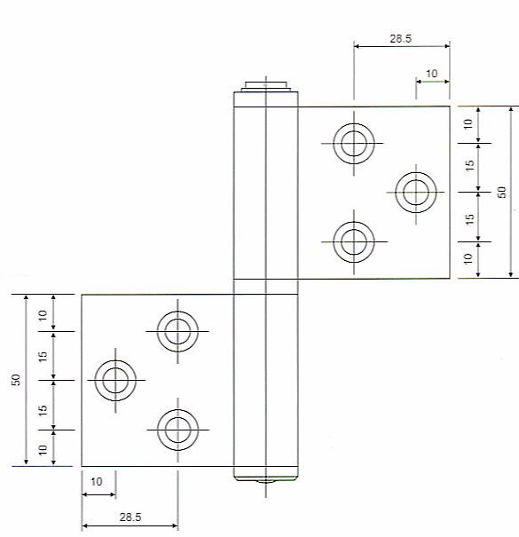

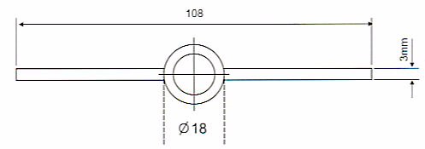

Rising Flag Hinge
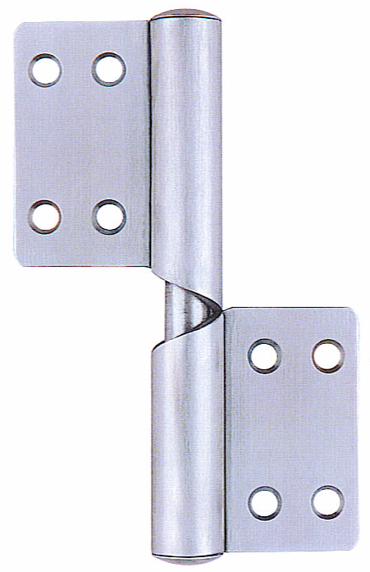

Sizes Available:
124mm x 4.5mm x 3mm

* Other sizes available upon special request

SS- Stainless Steel
PSS- Polished Stainless Steel
BP- Brass Plated
GP- Gold Plated (Shining)
AB- Antique Bronze
AC- Antique Copper

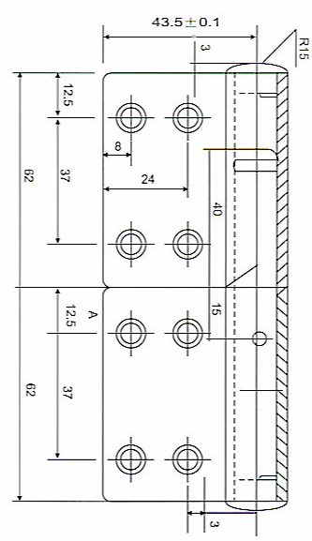

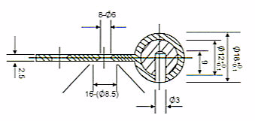

Flag Hinge with Washer

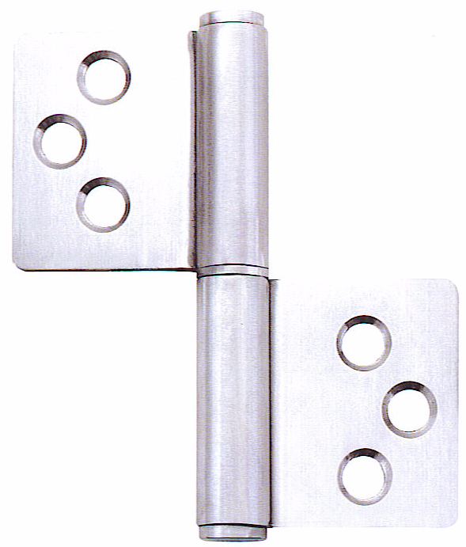

Sizes Available:
75.5mm x 70mm x 3mm

* Other sizes available upon special request

SS- Stainless Steel
PSS- Polished Stainless Steel
BP- Brass Plated
GP- Gold Plated (Shining)
AB- Antique Bronze
AC- Antique Copper

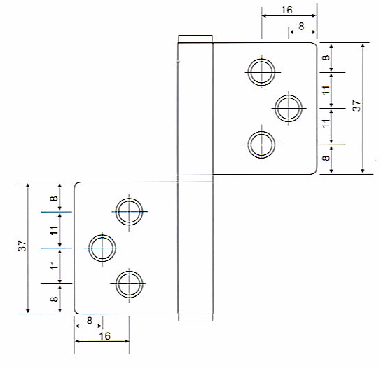

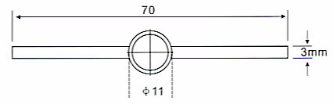

2 Ball Bearings Security Hinge

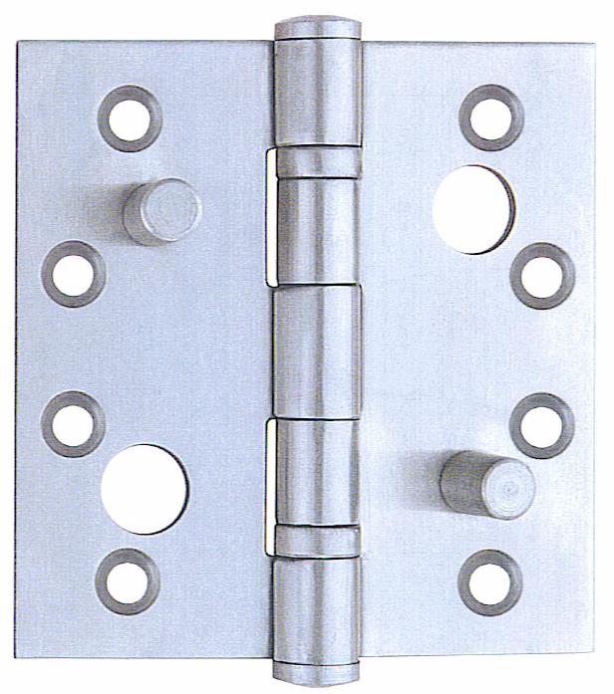

Sizes Available:
4” x 3” x 3mm
5” x 3.5” x 3mm

* Other sizes available upon special request

SS- Stainless Steel
PSS- Polished Stainless Steel
BP- Brass Plated
GP- Gold Plated (Shining)
AB- Antique Bronze
AC- Antique Copper

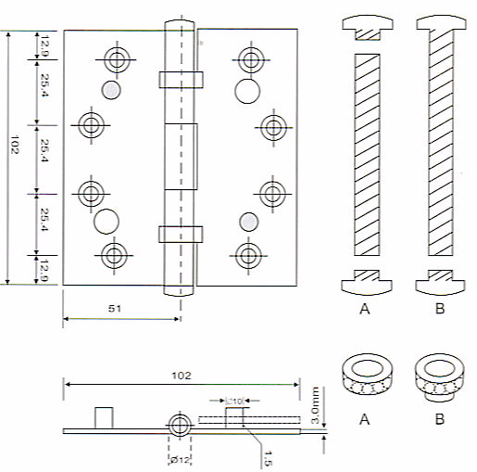

2 Ball Bearings Crank Hinge
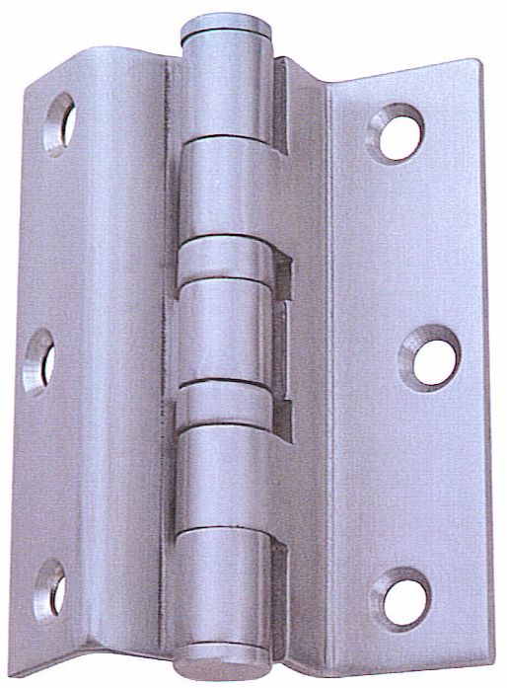

Sizes Available:
4” x 3” x 3mm

* Other sizes available upon special request

SS- Stainless Steel
PSS- Polished Stainless Steel
BP- Brass Plated
GP- Gold Plated (Shining)
AB- Antique Bronze
AC- Antique Copper

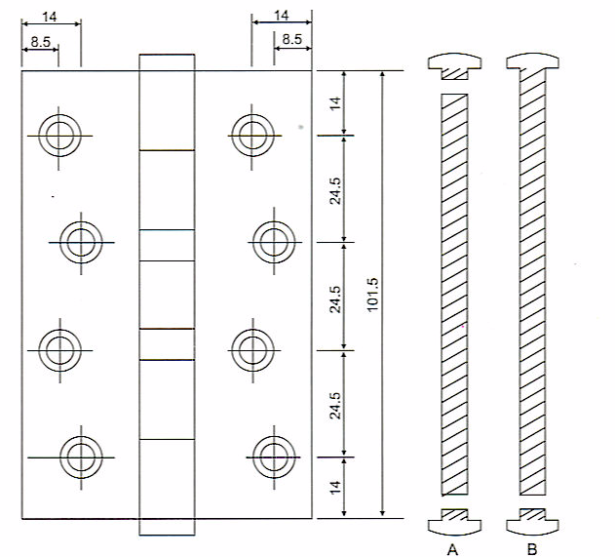

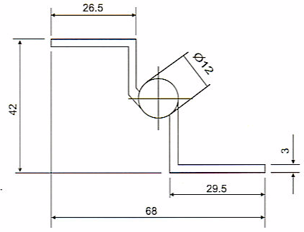

Double Action Spring Hinge

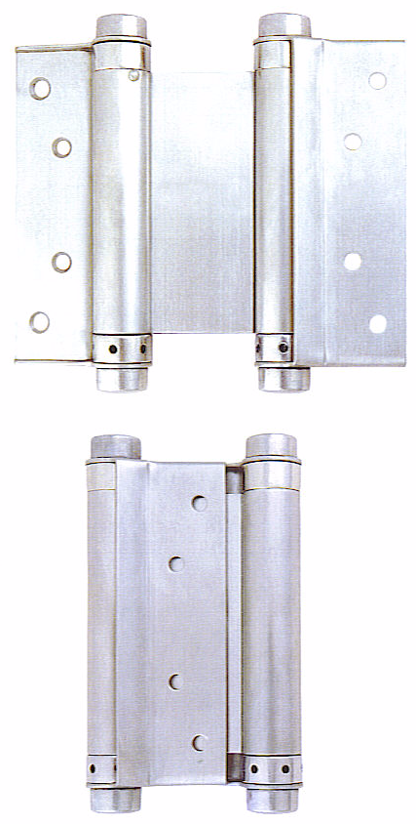
zes Available: Sizes Available:
4” x 3” x 3mm

* Other sizes available upon special request

SS- Stainless Steel
PSS- Polished Stainless Steel
BP- Brass Plated
GP- Gold Plated (Shining)
AB- Antique Bronze
AC- Antique Copper

A | B | C | D | E | F | G | H
4" | 40 | 16.5 | 23.5 | 25 | 16.3 | 5 | 54.5
5" | 47.5 | 15.5 | 32 | 25 | 17.5 | 5.5 | 64
6" | 51.5 | 16.5 | 35 | 25 | 17.5 | 5.5 | 70.5

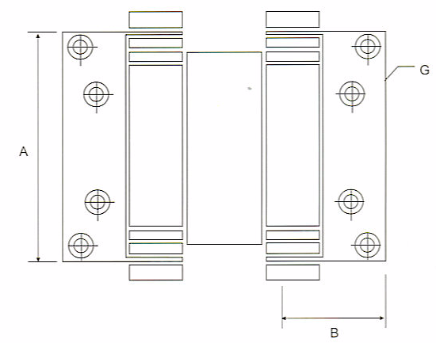

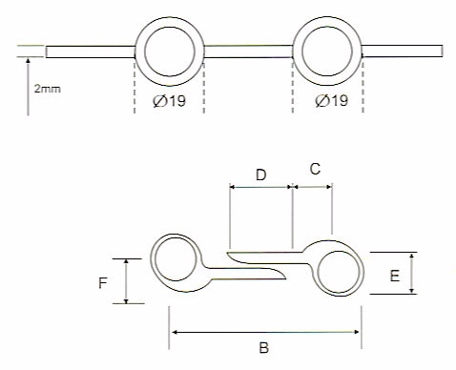

Double Action Spring Hinge
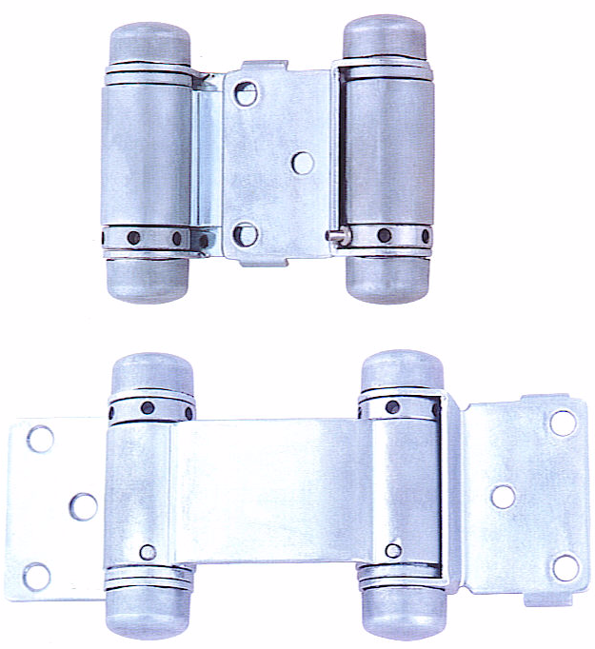

Sizes Available:
76mm x 156mm x 3mm

* Other sizes available upon special request

SS- Stainless Steel
PSS- Polished Stainless Steel
BP- Brass Plated
GP- Gold Plated (Shining)
AB- Antique Bronze
AC- Antique Copper

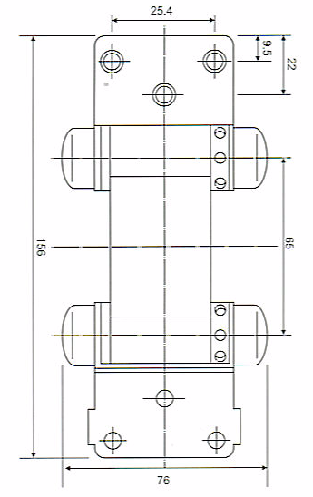

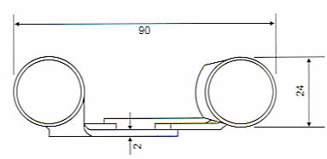

Single Action Spring Hinge

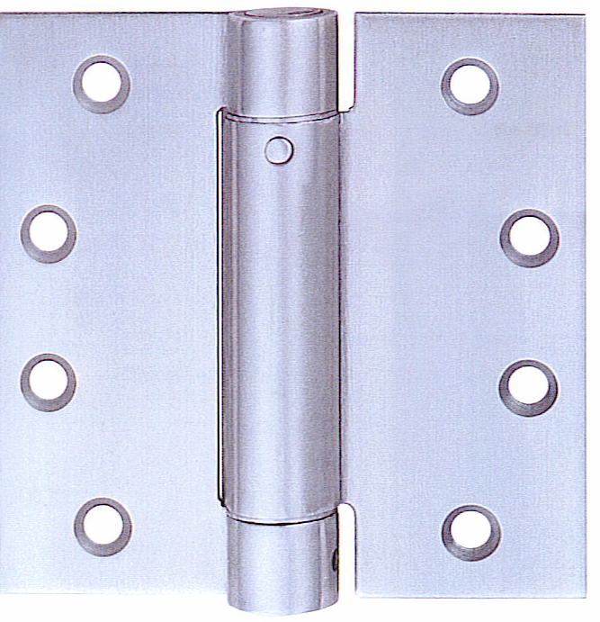

Sizes Available:
4” x 4” x 3mm

* Other sizes available upon special request

SS- Stainless Steel
PSS- Polished Stainless Steel
BP- Brass Plated
GP- Gold Plated (Shining)
AB- Antique Bronze
AC- Antique Copper

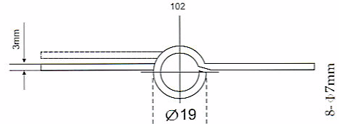
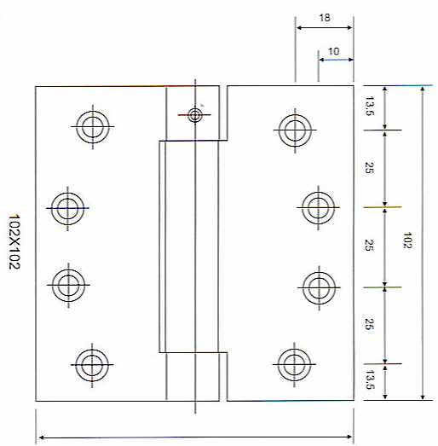

H Hinge
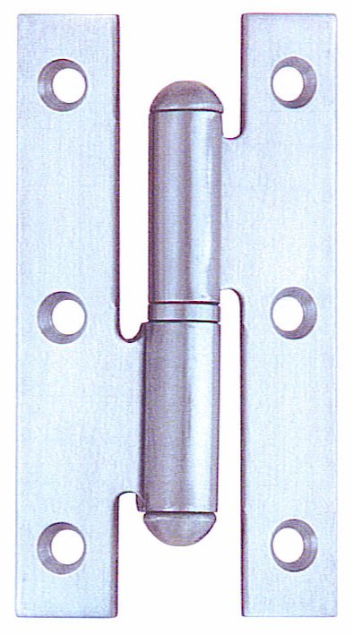

Sizes Available:
102mm x 71.2mm x 2mm
102mm x 71.2mm x 2.5mm

* Other sizes available upon special request

SS- Stainless Steel
PSS- Polished Stainless Steel
BP- Brass Plated
GP- Gold Plated (Shining)
AB- Antique Bronze
AC- Antique Copper

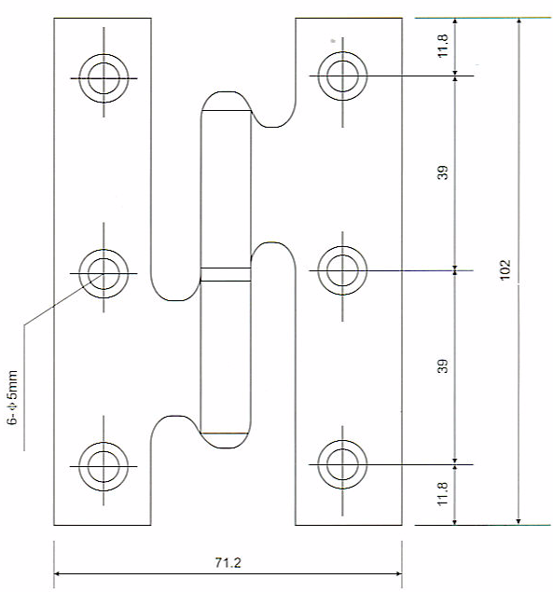

Flush Hinge

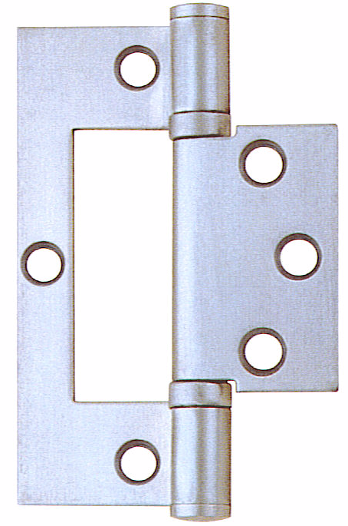

Sizes Available:
102 x 72.5 x 2.5mm

* Other sizes available upon special request

SS- Stainless Steel
PSS- Polished Stainless Steel
BP- Brass Plated
GP- Gold Plated (Shining)
AB- Antique Bronze
AC- Antique Copper

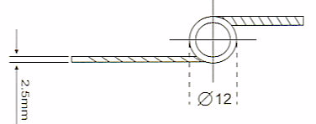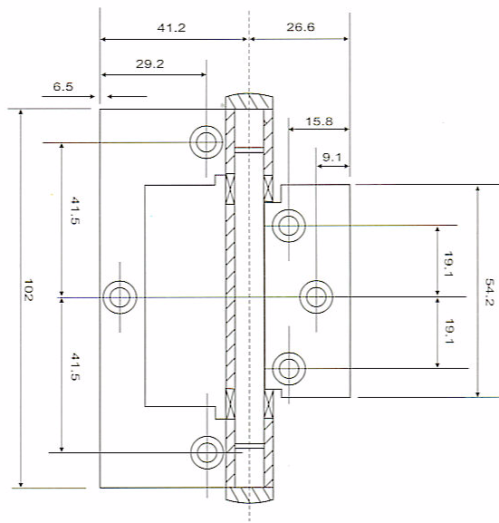

Flush Hinge

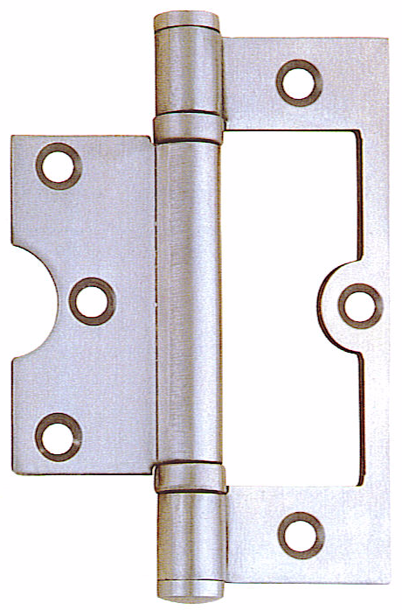

Sizes Available:
102 x 72.5 x 2.5mm

* Other sizes available upon special request

SS- Stainless Steel
PSS- Polished Stainless Steel
BP- Brass Plated
GP- Gold Plated (Shining)
AB- Antique Bronze
AC- Antique Copper

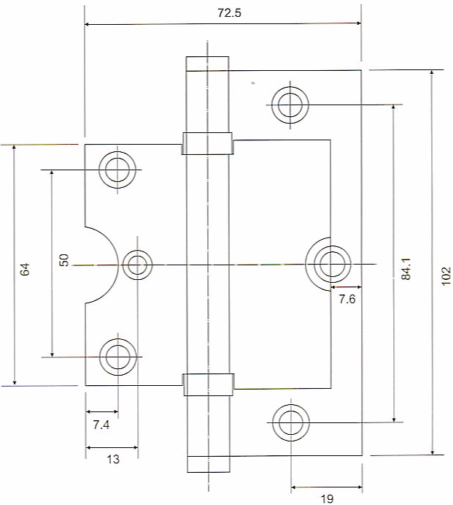

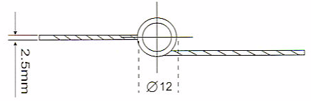

Pivot Hinge
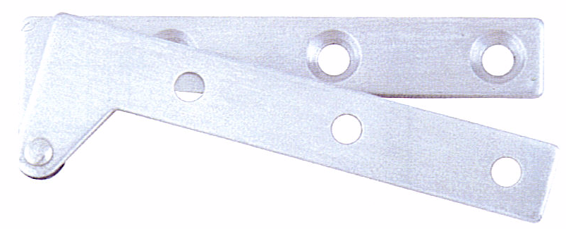

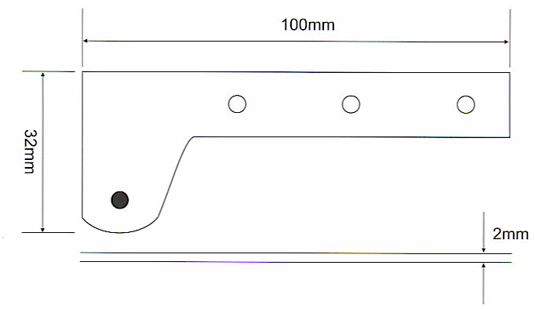

Sizes Available:
20mm x 50mm x 2mm
32mm x 100mm x 2mm

* Other sizes available upon special request

SS- Stainless Steel
PSS- Polished Stainless Steel
BP- Brass Plated
GP- Gold Plated (Shining)
AB- Antique Bronze
AC- Antique Copper

Three-Leaf Hinge

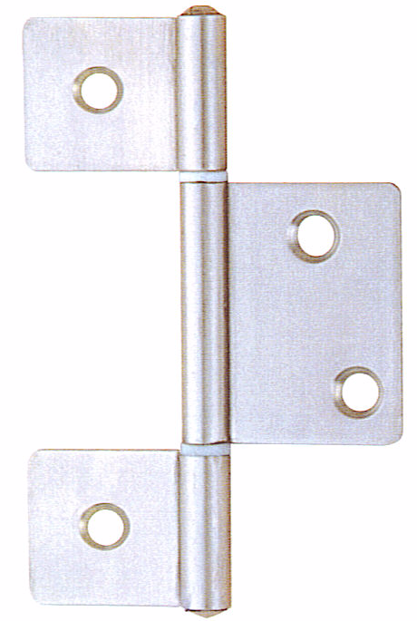

Sizes Available:
87.1mm x 59.4mm x 1.5mm

* Other sizes available upon special request

SS- Stainless Steel
PSS- Polished Stainless Steel
BP- Brass Plated
GP- Gold Plated (Shining)
AB- Antique Bronze
AC- Antique Copper

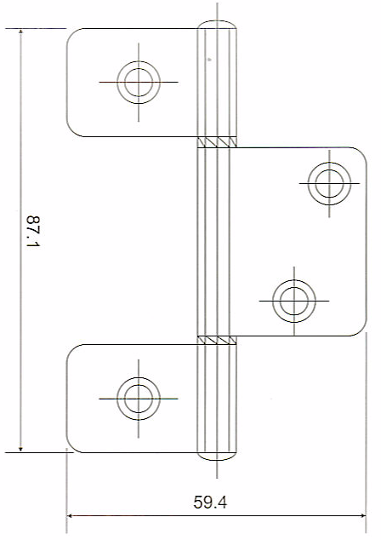

Parliament Hinge

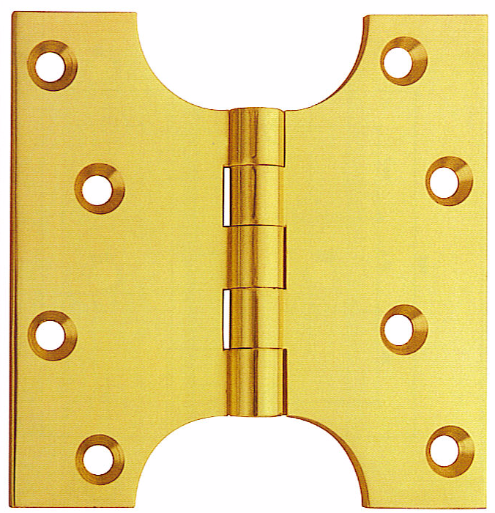izes Available:
4” x 4” x 4.0mm
4” x 5” x 4.0mm
4” x 6” x 4.0mm

* Other sizes available upon special request

SS- Stainless Steel
PSS- Polished Stainless Steel
BP- Brass Plated
GP- Gold Plated (Shining)
AB- Antique Bronze
AC- Antique Copper

