CONCEALED HINGE

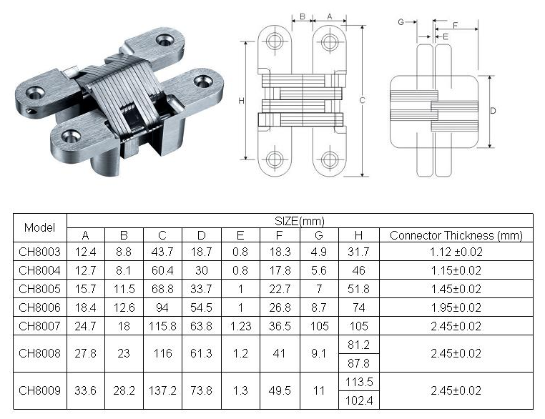

Material : SUS 304 Stainless Steel Or Zinc Alloy
Finish : Satin Stainless Steel (SSS)

